**MERN STACK**

**softwares:**

mongodb server edition exe

robo3T

vscode

nodejs install

postman

coggle.it (to create the mind mapping of the project)

**Notes:**

* To start mongoDB

"C:\Program Files\MongoDB\Server\4.2\bin\mongo.exe"

**Error codes:**

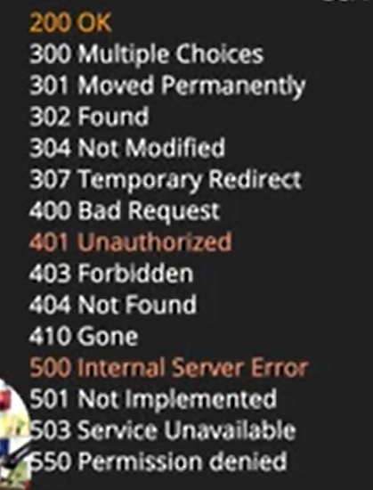

**Express** gave us the capability of routing, controllers and listening to various server response.Express can be config to listen on any port.

To install modules from package.json file use npm install.

SALT(cryptography) is used for hashing passwords.

We create the schema in models.

Virtual is used to calculate info on the go without asking specific details.(eg: we take a password and in virtual method we create a hashed method to encrypt the password and salt will be used for decryption.)

UUID is used in generating longer strings and is used for hashing passwords. For this we will be creating a method inside schema where we will be using uuid.

**Creating a Server**

Load the folders.

Then mention it as npm init. This creates a package.json file with the description of file. The adv is if we write npm install it will install all the dependencies at once.

Install express: npm i express.

Create index.js in the root dir or app.js.

Once nodemon is installed(npm install nodemon) change the script to nodemon index.js.And to start the server type npm start

**Mongoose**

It is a kind of object modelling for nodejs.

Writing schema of mongodb and connection.